Course : Diploma in Multimedia & Infocomm Technology (EGDF15)

Module : Java Enterprise Development (EG3752)

|  |  |
| --- | --- |
| Laboratory : | Lab 5 – Updates to the Database via JDBC and Basics of Pair Programming |
| Objectives : | At the end of this session, you should know how to:   * Use the JDBC API to update information to the database * Pair Programme |
| Software Used : | Java Standard Development Toolkit (JDK™) 8.0  NetBeans IDE 8.0 with GlassFish Server 4.0 bundle  MySQL Community Edition 5.7 or WAMP Server + MySQL Workbench 6.3 |
|  |  |
| References : | “Pair Programming” by Code.org  <https://www.youtube.com/watch?v=vgkahOzFH2Q> |

**Library Book Management System – Add Book**

Extend the previous lab with an additional add book function. The additional requirement specifications for the project are listed as follows:

|  |  |
| --- | --- |
| **Requirement Reference** | **Requirement Specifications** |
| 2.1 Add Book | The system shall provide the functionality for users add a new book into the system.  The system shall validate all data input by the user. In particular, the system will have to verify that a valid ISBN number is provided. |

Below is a sequence diagram showing how the different components of the web application will be interacting with each other:

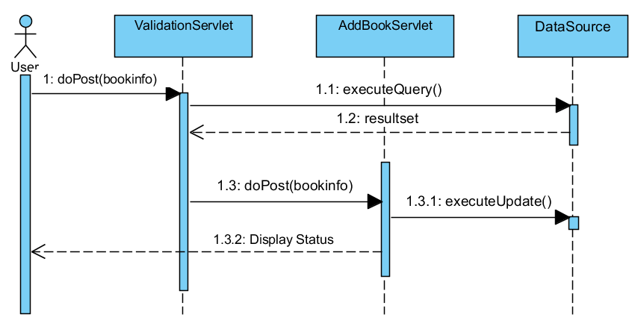

Pair Programming

In this lab, you **MUST** work in pairs.

**Pair programming** is an agile software development technique in which two programmers work together at one workstation. One, the *driver*, writes code while the other, the *observer* or *navigator*, reviews each line of code as it is typed in. The two programmers switch roles frequently. While reviewing, the observer also considers the "strategic" direction of the work, coming up with ideas for improvements and likely future problems to address. This frees the driver to focus all of his or her attention on the "tactical" aspects of completing the current task, using the observer as a safety net and guide. *(Source: Wikipedia)*

Your instructor will show you a video regarding pair programming. The link is provided on the first page of the lab sheet should you like to review the video again. The tips on pair programming as shared in the video are listed below for your easy reference:

**Dos:**

* Be respectful
* Talk to one another about the work
* Explain what you are doing
* Think ahead and make suggestions
* Switch roles often

**Don’ts:**

* Be a bossy navigator
* Grab the driver’s mouse/keyboard

Suggested Screens for the Application

The following are screenshots suggested for the landing page of the add function:

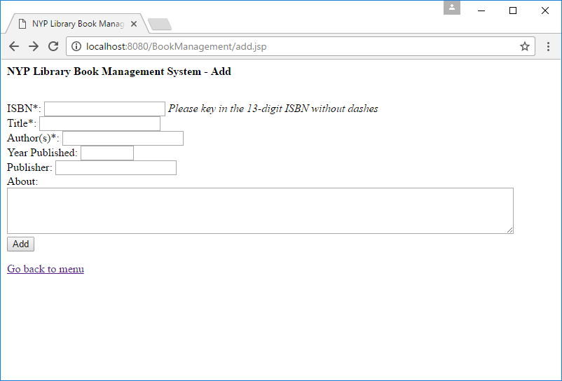

Landing Page of the Add function of the NYP Library Book Management System

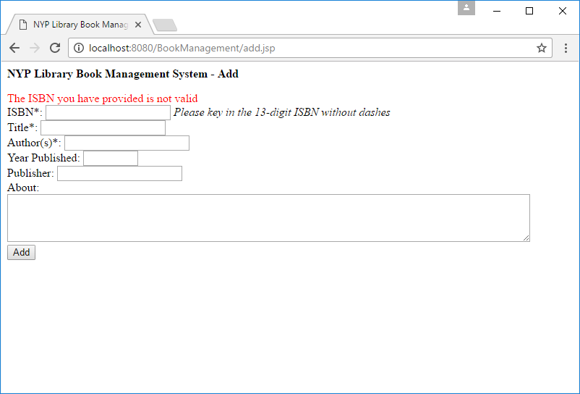

Message displayed when the information provided does not pass a validation process

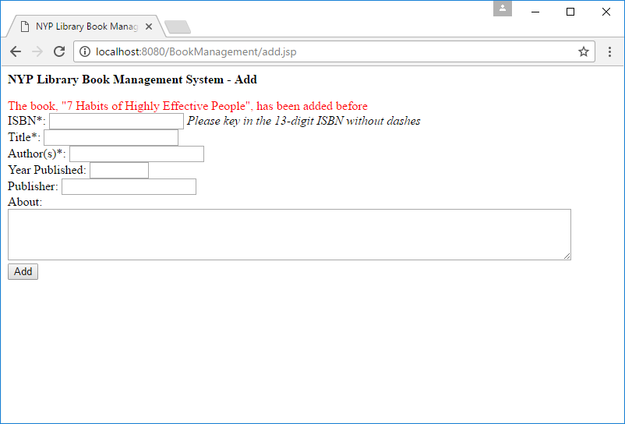

Message displayed when the user attempts to add a book that has been added before

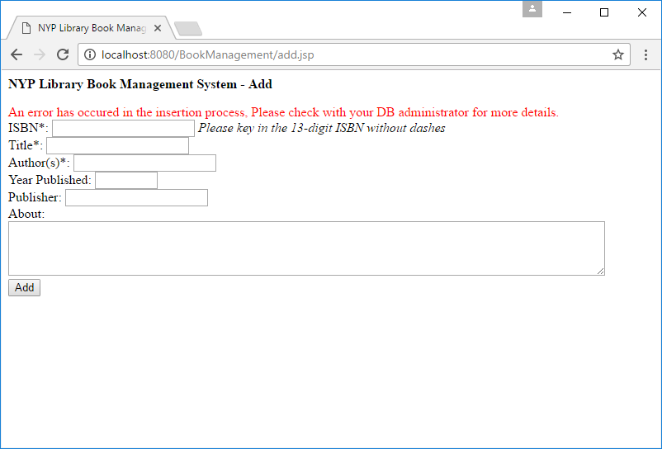

Message displayed when there is a database error when attempting to add a book

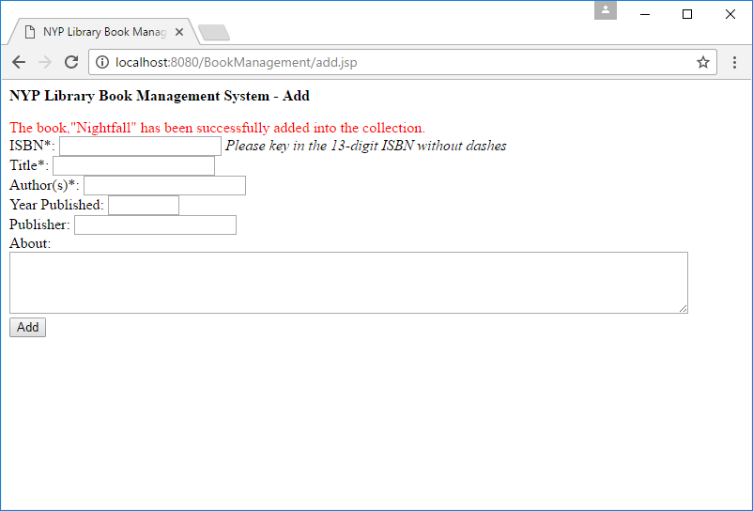

Message is also displayed when a book is successfully added

Differences in Coding the JDBC portion

As we are doing an update to the database, we will be implementing transactions to manage possible exceptions that may occur when making database operations.

To implement transactions for this application, note the following difference that is required in the coding:

* 1. After the connection has been retrieved from the data source, set auto commit to false:

connection.setAutoCommit(false);

* 1. Immediately after the group of transactions has been completed, call commit to confirm the changes to be made to the database:

connection.commit();

* 1. Within the catch clause where an SQLException has occur, call a for a rollback to reject all transactions that happen within the group of transactions:  
       
     connection.rollback();
  2. Before closing the connection, set auto commit back to true:  
       
     connection.setAutoCommit(true);

Adjusting the Difficulty of the Lab

As you will be working in pairs, this lab is also designed to be more difficult than usual. You may choose to lower the difficulty of the lab by doing the following:

* **Limit the Year to between 1000 and 9999**

This will reduce additional checks and conversions required for years that does not contain exactly four digits.

* **Making all fields compulsory**

This will remove dynamic creation of SQL statements that needs to be considered depending on whether the user has keyed in a particular field or not.

The proposed solution implements the latter feature.

Optional Exercise: Updating Book Details and Deleting Books

Enhance the book catalogue management system with two additional functions, updating the details of existing books and deleting books in the catalogue. You may find it useful to implement a function similar to the one in Lab 4 to search for the exact books for updating and deletion.